Introduction: 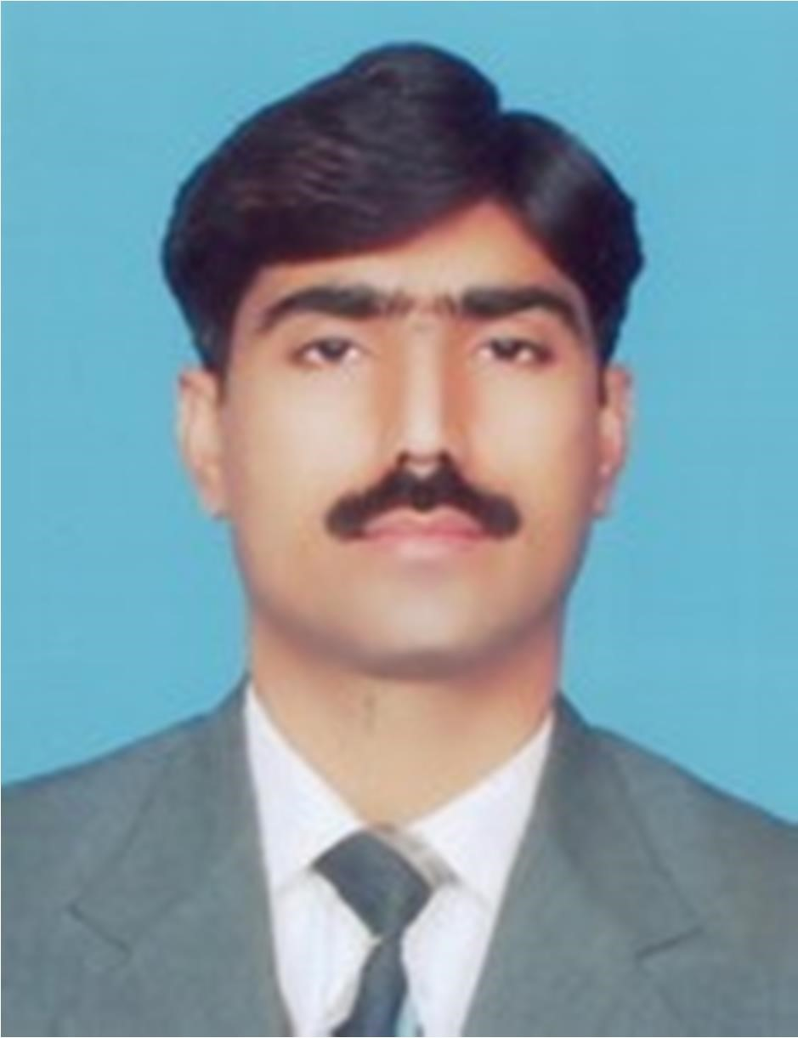

GUL SHER

Email Address: gulsherchadher74@yahoo.com gulsherchadher74@gmail.com
Cell: +92 321 7662688
+92 324 2103325 (WhatsApp)

An accounting and finance professional having more than 25 years of work experience at various positions from accounts assistant to Manager Accounts / Finance with different industries / organizations, of managing all affairs pertaining to finance and accounts, costing and budgeting, taxation, corporate and internal audit.
Qualification:
Professional:
- CMA (Cost and Management Accountant) - Institute of Cost & Management Accountants of Pakistan (ICMAP), Karachi
- AAT (Foundation Completed) - Pakistan Institute of Public Finance Accountants (PIPFA), Karachi
Academic:
- Graduation (B.Com.) - University of Punjab, Lahore, Pakistan 1994
- Intermediate (F. Sc. Math., Stat. & Economics) – B.SI.S.E. Faisalabad 1991
- Matriculation (Science) - B.SI.S.E. Faisalabad 1989
Computer Skills:
I have hands on exposure to various ERPs in Oracle, retail industry software “Candela” and “Microsoft Dynamics AX 2012”.
Also, I have proficient command in MS Excel. and MS Word.
SUMMARY OF WORK EXPERIENCE
Over all more than 28 years of work experience in manufacturing and retail industry (mostly in textile)
- Working as Manager Accounts in RAFIQ JAMIL TEXTILE INDUSTRIES PVT. LIMITED; OKARA since March 19, 2024 to date.
- Working as Manager Accounts and Taxation in MAJEED FABRICS PVT. LIMITED; FAISALABAD since April 30, 2022 to March 18, 2024.
- Worked as Manager Accounts in Sitara Studios (Pvt.) Ltd. Faisalabad; a retail sale company a part of renowned leading textile group “Sitara Group of Companies Faisalabad” from June 28 2020 to April 29, 2022.
- Worked as Manager Accounts in Maypole (Pvt.) Ltd. Lahore; (Leading Ladies Suits Brand “LimeLight”) (February 01, 2019 to March 31, 2020)
- Worked as Manager Accounts and Taxation in CHALLENGE APPARELS LIMITED; FAISALABAD (Pakistan China Joint Venture) (September 2015 to January 2019)
- Worked as Finance Manager in TAHIR RAFIQUE TEXTILE MILLS FAISALABAD; (August 2014 to August 2015)
- Worked as Finance Manager in D. M. TEXTILEMILLS LIMITED RAWALPINDI; (Listed on Karachi & Islamabad Stock Exchanges) (Oct 2013 to August 2014)
- Worked as Accounts Manager in CHF INTERNATIONAL LIMITED; FAISALABAD & KARACHI (USA & Hong Kong Based Co.) (Feb, 2007 to Oct 2013)
- Worked as Chief Accountant in BILAL TEXTILES (PVT) LIMITED; FAISALABAD (Aug 2005 to Jan 2007)
- Worked as Chief Accountant (MIS / Implementation) in ZAHIDJEE GROUP; FAISALABAD (April 2004 to Aug 2005)
- Worked as Accountant in SHAH JEE WEAVING FACTORY; FAISALABAD (March 2002 to April 2004)
- Worked as Accountant in PETROCON (PVT) LIMITED; ISLAMABAD & KARACHI (Nov 1999 to Oct 2001)
- Worked as Accounts Officer in MR. FABRICS (PVT) LIMITED; LAHORE (Dec 1995 to Jul 1999)

Detailed Professional Experience
RAFIQ JAMIL TEXTILE INDUSTRIES PVT. LIMITED; OKARA
(March 2024 to date)
Position: Manager Accounts
Reporting to Director
Major Job Responsibilities:

- Supervision of books of accounts.
- Supervision / Checking of all types of accounting vouchers.
- Supervision of final accounts on monthly & annual basis.
- To prepare accounts for audit and coordinate the external auditors during audit.
- Preparation of various monthly reports for Management.

MAJEED FABRICS PVT LIMITED; FAISALABAD
(May 2022 to March 2024)

Position: Manager Accounts and Taxation
Reporting to CEO

Major Job Responsibilities:

- Supervision of books of accounts.
- Supervision / Checking of all types of accounting vouchers.
- Supervision of final accounts on monthly & annual basis.
- To prepare accounts for audit and coordinate the external auditors during audit.
- Preparation of various monthly reports for Management.
- To deposit income tax withheld at source on time
- To timely filing of quarterly statements of income tax withheld
- To ensure timely filing of annual return of total income of company.
- To file monthly sales tax return
- To liaison / correspond with RTO Faisalabad for tax notices & other matters.
SITARA STUDIOS (PVT.) LIMITED; FAISALABAD (Leading Suits Brand “Sitara”) A retail Sale Company a part of renowned leading textile group “Sitara Group of Companies
(June 2020 to date)

Position: Manager Accounts and Finance
Reporting to CEO / CFO

Major Job Responsibilities:

- Preparation of Monthly Profit / Loss Statements of Company Shops
- Preparation of daily and monthly sales report, sales target lags report and sales VS stock report
- Working of Commission on Sales of sales base vendors, franchise and web-portal for online sales
- Working of receipts and courier charges from courier against online sales
- Working of receipts and bank charges against credit card sales
- Preparation of various monthly reports for Management.
- Supervision of all accounting operations hitting Trial Balance
- Supervision of Monthly Closing of Financial Data Feeding in FAS
- Monitoring of daily sales, cash (against sales) deposit into banks, credit card sales
- Supervision of daily cash / bank position.
- Supervision, checking and editing of all types of accounting vouchers.
- Supervision and opening of Chart of Accounts and vendors in software “Microsoft Dynamics AX 2012.
- Supervision of Monthly Salaries and commission of sales staff of all Segments
- Supervision of Income Tax Withheld of Vendors & Salaries and Payment thereof
- Preparation and filing of Monthly Sales Tax Return
- To coordinate IT personnel for development, implementation and trouble shooting in software “Microsoft Dynamics AX 2012.
- To manage to pay accounts payable timely.
MAY POLE (PVT.) LIMITED; LAHORE (Leading Ladies Suits Brand “LimeLight”)
(February 2019 to April 2020)

Position: Manager Accounts
Reporting to CEO

Major Job Responsibilities:
- Supervision of trial balance
- Supervision of Monthly Closing of Financial Data Feeding in FAS (Factories, Own Shops, Franchises, Partnership shops)
- Preparation of Monthly Profit / Loss Accounts of Partnership and own Shops
- Working of Commission on Sales (Franchise & Partnership Shops)
- Preparation of various monthly reports for Management.
- Supervision of daily cash / bank position.
- Supervision, checking and editing of all types of accounting vouchers.
- Supervision and opening of Chart of Accounts and Chart of Items.
- Checking / Supervision of Monthly Salaries of all Segments
- Reconciliation of Salaries Payable Ledger
- Supervision of Income Tax Withheld of Vendors & Salaries and Payment thereof
- Supervision of Advance Income Tax
- Supervision of Input Sales Tax
- Supervision / Reconciliation of Sales Tax and Income Tax on Imports
- To coordinate IT personnel for development, implementation and trouble shooting in FAS & IMS
- To supervise stores purchase, issuance, consumption.
- To manage to pay accounts payable timely.

CHALLENGE APPARELS LIMITED; FAISALABAD (Pakistan China Joint Venture)
(September 2015 to January 2019)

Position: Manager Accounts
Reporting to CFO / DGM

Major Job Responsibilities:

- Supervision of books of accounts.
- Supervision / Checking of all types of accounting vouchers.
- Supervision of daily cash/bank position.
- Supervision of final accounts on monthly & annual basis.
- To prepare accounts for audit and coordinate the external auditors during audit.
- Preparation of various monthly reports for Management.
- To coordinate IT personnel to make different MIS reports as per requirement.
- To supervise stores purchase, issuance, consumption.
To manage to pay accounts payable timely.
- To deposit income tax withheld at source on time
- To ensure timely filing of monthly and annual statements of income tax withheld
- To ensure timely filing of annual return of total income of company.
- To file monthly sales tax return
- Supervision of monthly stock taking of store supplies.
- To liaison / correspond with SECP for filing of statutory returns and forms.
- To liaison / correspond with RTO Faisalabad for tax notices & other matters.
- To liaison with insurance companies for general insurance of company’s assets.

TAHIR RAFIQUE TEXTILE MILLS FAISALABAD;
(August 2014 to August 2015)
Position: Finance Manager
Reporting to CEO

Major Job Responsibilities:

- Supervision of books of accounts.
- Supervision / Checking of all types of accounting vouchers.
- Supervision of daily cash/bank position.
- To prepare accounts for audit and coordinate the external auditors during audit.
- Preparation of various monthly reports for CEO.
- To coordinate IT personnel to make different MIS reports as per requirement.
- To manage to pay accounts payable timely.
- To ensure timely filing of monthly and annual statements of income tax withheld
- To ensure timely filing of annual return of total income of company.
- To ensure timely filing of monthly sales tax return.
- To check daily production report.
- Supervision of monthly stock taking of raw material and WIP.
- To liaison / correspond with banks for financing facility.

D. M. TEXTILEMILLS LIMITED RAWALPINDI; (Listed on Karachi & Islamabad Stock Exchanges)
(Oct 2013 to August 2014)
Position: Finance Manager
Reporting to CEO

Major Job Responsibilities:

- Supervision of books of accounts.
- Supervision / Checking of all types of accounting vouchers.
- Supervision of daily cash/bank position.
- Supervision of final accounts on monthly, quarterly& annual basis.
- To prepare accounts for audit and coordinate the external auditors during audit.
- Preparation of various monthly reports for CEO.
- To coordinate IT personnel to make different MIS reports as per requirement.
- Preparation of annual budget.
- To manage to pay accounts payable timely.
- To ensure timely filing of monthly and annual statements of income tax withheld
- To ensure timely filing of annual return of total income of company & CEO.
- To ensure timely filing of monthly sales tax return.
- To check daily production report.
- Supervision of monthly stock taking of raw material and WIP.
- To liaison / correspond with SECP for filing of statutory returns and forms.
- To liaison / correspond with LTU Islamabad for tax notices & other matters.
- To liaison / negotiation with Insurance companies for general insurance of company’s assets and for group life insurance of employees.

CHF INTERNATIONAL LIMITED; KARACHI (USA & Hong Kong Based Co.)
(Feb, 2007 to Oct 2013)
Position: Accounts Manager
Reporting to Country Head

Major Job Responsibilities:

- Supervision / Maintenance of books of accounts.
- Checking of all types of accounting vouchers.
- Supervision of daily cash/bank position.
- Preparation of final accounts on monthly & annual basis.
- Preparation of various monthly reports for Country Head.
- Preparation of annual budget.
- To manage to pay accounts payable timely.
- To ensure timely filing of monthly and annual income tax statements.
- To prepare accounts for audit and coordinate the external auditors during audit.
- To coordinate IT personnel to make different MIS reports as per requirement.

BILAL TEXTILES (PVT) LIMITED; FAISALABAD
(Aug 2005 –Jan 2007)

Position: Chief Accountant
Reporting to Manager Finance & CEO

Major Job Responsibilities:

- Supervision / Maintenance of books of accounts.
- Checking of all types of accounting vouchers.
- Supervision of daily cash/bank position.
- Preparation of final accounts on monthly basis for management.
- Preparation of various monthly reports for CEO.
- To check daily production report.
- To check daily electricity generation and gas consumption report.
- To ensure timely filing of sales tax return and supervision of maintenance of sales tax record.
- To manage to pay accounts payable timely.
- To prepare, deposit and file monthly electricity duty return timely on in-house electricity generation.
- To ensure timely filing of monthly and quarterly income tax return.
- To coordinate IT personnel to make different MIS reports as per requirement.

ZAHIDJEE GROUP; FAISALABAD
(April 2004 –Aug 2005)

Position: Chief Accountant (MIS/Implementation)
Reporting to Manager Finance & CEO

Major Job Responsibilities:

- Worked as an implementation team member for testing, configuring and implementation of newly acquired financial solution, from a multinational software house, KPMG.
- Worked as an implementation team member for testing, configuring and implementation of various newly in house developed soft wares such as Cloth Management Systems (Grey as well as Processed), Yarn (Purchase / Sale) Management Systems, etc.

Position: Chief Accountant (Spinning & Power House)
Reporting to Manager Finance & CEO

Major Job Responsibilities:

- Maintenance of books of accounts.
- Checking of mills vouchers.
- Preparation of final accounts on monthly basis.
- Preparation of various monthly reports for CEO.
- To check daily production report.
- To check daily generation and consumption of electricity units.
- To manage to pay SNGPL & WAPDA bills timely.
- To manage to pay accounts payable timely.
- To prepare, deposit and file monthly electricity duty return timely on in-house electricity generation.
- To ensure timely filing of quarterly income tax return.

SHAH JEE WEAVING FACTORY; FAISALABAD
(March 2002– April 2004)

Position: Accountant
Reporting to Proprietor

Major Job Responsibilities:

- Performed all accounting tasks, Complete handling of Sales Tax Matters, Costing of yarn / conversion costs for cloth making and Stock management independently

PETROCON (PVT) LIMITED; ISLAMABAD
(Nov 1999– Oct 2001)

Position: Accountant
Reporting to Managing Director

Islamabad Office (Nov 1999 to Mar 2000)

Major Job Responsibilities:
Performed accounting tasks, checking of all accounting record and miscellaneous tasks related to tenders & bids

Karachi Office (Apr 2000 to Oct 2001)

Major Job Responsibilities:
- Performed accounting tasks, internal auditing tasks, cash management, accounts payable.
- Coordinated project director in preparation of tenders / bids for projects.
- Coordinated project director in preparation of progress construction bills.
- Attended meetings held with clients (SSGPL, SHELL, PSO, CWO, etc.) for tender opening on behalf of company.
- Several times visited the work site at JINNAH NAVAL BASE ORMARA, DISTRICT GAWADR, BALOCHISTAN (A project of MES – Navy Pakistan, for construction of Ready Use Fuel Tanks for fueling / defueling of naval ships & aircrafts.)
MR. FABRICS (PVT) LIMITED; LAHORE
(Dec 1995– Jul 1999)

Position: Accounts Officer
Reporting to Chief Accountant/Managing Director

Major Job Responsibilities:
- Maintenance of complete book keeping record manually as well as computerized.
- Handling of all tasks related to refund of sales tax independently.
- Supervision of all record related to store.
- Reconciliation of Bank statements.
- Preparation of annual accounts.
- Independently prepared accounts for audit and coordinated the external auditors during audit for four years, (94-95, 95-96, 96-97 & 97-98).

